YUVAINTERN
Computer Vision Specialist Internship

WEEK 4 TASK REPORT
Integration of Computer Vision Solutions and Cross-functional Testing

Intern Name | Pragyan Parimita Nayak
Project | Real-Time Retail Shelf Object Detection and Counting
Internship Role | Computer Vision Specialist
Task | Week 4: Integration of Computer Vision Solutions and Cross-functional Testing
Internship Period | 01-Oct-2026 to 29-Oct-2026
CV Component | Week 3 structured-pruned TinyShelfDetector
Integration Method | REST API over local HTTP + JSON
Downstream Component | Simulated Inventory Adapter

1. Task Requirement Mapping
The Week 4 YuvaIntern task asks for a small-scale prototype in which a computer vision module interacts with other software components. The submission is expected to include integration code using an API or simulation framework, a functional prototype, a detailed integration strategy, challenges, end-to-end test cases/results, and unit and system testing. The work is also expected to represent approximately 30–35 hours of practical effort. fileciteturn1file0L225-L299
YuvaIntern requirement | Implementation | Evidence
Select an application context | Retail shelf monitoring and object counting | Functional prototype
Integration plan | Client → REST API → preprocessing → CV model → detection decoder → inventory adapter | Architecture diagram
RESTful/API communication | GET /health and POST /analyze with JSON payload | shelf_api.py
Modular integration | CV model and downstream InventoryAdapter are separate components | Application source
Unit + system testing | 7 automated tests, including preprocessing, adapter logic and live HTTP requests | test_week4.py
Document challenges and results | Architecture, validation behaviour, end-to-end results and limitations documented | This report

2. Application Context
The final prototype is a simple retail shelf monitoring service. A client submits an image of a shelf to the API. The computer vision module preprocesses the image, runs the optimized Week 3 detector and converts the model output into bounding boxes. The detected object count is then passed to a simulated InventoryAdapter, representing a downstream business component that could consume shelf-count events.
This context was chosen because it keeps the same problem definition used throughout Weeks 1–3. It also makes the interaction between a computer vision module and a non-vision software component visible: the computer vision layer produces a structured count, while the downstream adapter converts that count into a shelf-monitoring event.

3. System Architecture
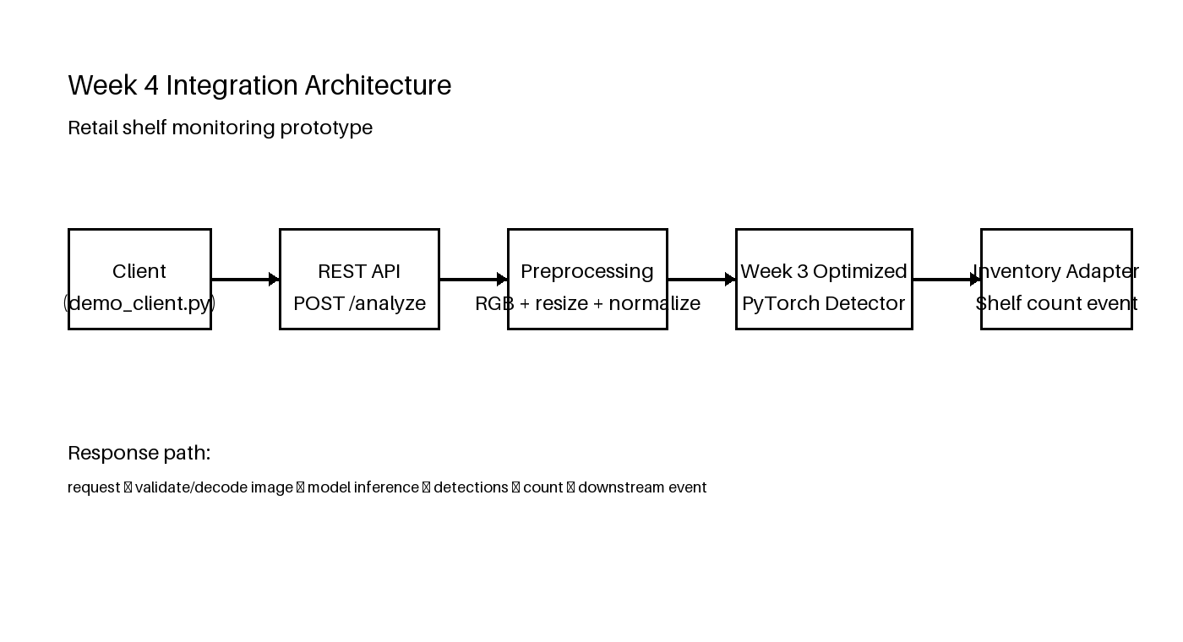
Figure 1. Week 4 integration architecture.
The prototype is intentionally small. It does not attempt to implement a complete retail inventory system, database or user interface. The objective is to prove that the optimized computer vision component can be called by another application component and that the returned result can be passed onward in a defined format.

4. Component Responsibilities
Component | Responsibility | Output
Demo client | Reads a sample image, encodes it as base64 and sends JSON request. | HTTP POST request
REST request handler | Validates route and request body and returns JSON response. | HTTP status + JSON
Preprocessing module | Decodes image, converts to RGB, resizes to 128×128 and normalizes pixels. | PyTorch tensor
Optimized CV model | Runs the Week 3 pruned detector. | Model prediction tensor
Detection decoder | Applies confidence threshold and converts grid output to normalized boxes. | Detection list + count
InventoryAdapter | Consumes count and creates a simulated shelf event. | SHELF_COUNT_UPDATE JSON

5. API Contract
Method | Endpoint | Input | Response
GET | /health | None | Service status
POST | /analyze | JSON: image_base64, shelf_id | Detection count, boxes, inference time and downstream event
The API uses JSON over HTTP so that the vision component is independent from the calling application. The downstream event is also JSON, which keeps the boundary between computer vision and the simulated inventory component simple.

6. Integration Workflow
1. The client reads a shelf image and encodes the image bytes as base64.
2. The client sends a POST request to /analyze with the encoded image and shelf identifier.
3. The request handler validates the JSON body and decodes the image.
4. The preprocessing function converts the image to RGB, resizes it to 128×128 and normalizes pixel values.
5. The Week 3 optimized model runs inference using PyTorch inference mode.
6. The prediction tensor is decoded into normalized bounding boxes using the same grid representation used in the previous tasks.
7. The number of detections is sent to InventoryAdapter.
8. InventoryAdapter creates a SHELF_COUNT_UPDATE event and the API returns both computer vision results and the downstream event.

7. Integration Code Design
The code is split into small functions and classes rather than placing the complete workflow inside the HTTP request handler. This makes each part easier to test separately. The main separation is between image preprocessing, model inference, detection decoding, API transport and downstream event generation.
detections = decode_detections(prediction)
event = self.inventory.build_event(
shelf_id, len(detections), inference_ms
)
return {
"status": "ok",
"detection_count": len(detections),
"detections": detections,
"downstream_event": event
}
The example shows the integration point between the CV module and the downstream component. The detector does not directly update inventory state; it produces a structured event that another component can consume.

8. Functional Prototype Verification
A real HTTP request was sent to the running local API using a sample shelf image. The request returned HTTP 200 and produced a detection count of 5. The downstream event was created with event type SHELF_COUNT_UPDATE for shelf A-01.
The measured model inference time recorded inside that request was 8.825 ms. The detection output contained 5 returned boxes. This demonstrates the complete path from image input through model inference to a downstream JSON event.

9. Example API Response
{
"status_code": 200,
"status": "ok",
"model": "week3_pruned_tinyshelf_detector",
"detection_count": 5,
"inference_ms": 8.825,
"downstream_event": {
"event_type": "SHELF_COUNT_UPDATE",
"shelf_id": "A-01",
"detected_count": 5,
"minimum_expected_count": 5,
"review_required": false,
"inference_ms": 8.825
}
}

10. Unit Testing
Unit tests focus on functions or isolated component behaviour. The preprocessing test verifies the tensor shape and original image metadata. The InventoryAdapter test verifies the downstream business rule when the detected count falls below the configured minimum.
Test | Type | Expected | Result
test_preprocess | Unit | Tensor shape is 1×3×128×128 | PASS
test_inventory_adapter_low_count | Unit | Low count creates review_required=true | PASS

11. System and End-to-End Testing
System tests exercise the HTTP service as a running application. The final automated run contained seven tests and all seven passed. This includes a real end-to-end POST /analyze request that loads the optimized model, processes the image and returns a downstream event.
Test | Endpoint/Component | Expected result | Actual | Status
Health check | GET /health | HTTP 200 | HTTP 200 | PASS
Missing body | POST /analyze | HTTP 400 | HTTP 400 | PASS
Invalid base64 | POST /analyze | HTTP 400 | HTTP 400 | PASS
End-to-end analysis | POST /analyze | HTTP 200 + detections + downstream event | HTTP 200 + event returned | PASS
Unknown route | GET /unknown | HTTP 404 | HTTP 404 | PASS
Preprocessing | preprocess_image() | 128×128 RGB tensor | Verified | PASS
Inventory adapter | InventoryAdapter | Low count flagged for review | Verified | PASS
Automated test command: python -m unittest discover -s tests -p "test_*.py" -v
Recorded result: 7 tests executed, 7 passed, 0 failures, 0 errors.

12. Repeated API Test
In addition to the unit and system test suite, the local API was exercised with 20 consecutive POST /analyze requests using the same sample image and shelf ID. All 20 requests returned HTTP 200.
Measurement | Recorded result
Requests | 20
Successful HTTP 200 responses | 20/20
Median HTTP response time | 4.347 ms
Mean HTTP response time | 5.299 ms
P95 HTTP response time | 6.369 ms
Detected count across requests | 5 on all 20 sample requests

13. Challenges Encountered
• The model was trained on the small synthetic development distribution from Weeks 2 and 3, so the integration has to be treated as a software prototype rather than a production retail detector.
• Transporting image data through JSON requires base64 encoding, which increases request size. A production system could use multipart upload or object-storage references instead.
• The local service uses a standard-library HTTP server to keep the prototype dependency-light. A production deployment would normally add a mature web framework, authentication, request limits and structured logging.
• The current model returns a single generic object class. The downstream component therefore receives a count of detected objects rather than SKU-specific inventory identities.

14. Error Handling
• Requests without a body are rejected with HTTP 400.
• Requests without image_base64 are rejected with HTTP 400.
• Malformed base64 is rejected with HTTP 400.
• Unknown API routes return HTTP 404.
• Unexpected processing errors return HTTP 500 with an internal-processing message.
These behaviours were included because an integration test should cover both the successful path and basic invalid-input paths, rather than only showing one successful prediction.

15. Security and Production Considerations
• The prototype binds to 127.0.0.1 during testing and is not presented as an internet-facing service.
• A production service should add authentication/authorization, maximum payload size, rate limiting, HTTPS and structured audit logging.
• Uploaded images should be validated by size and format before processing to reduce denial-of-service and malformed-file risks.
• The downstream inventory adapter is only a simulation. No real inventory database is modified by this prototype.

16. Project Structure
Path | Purpose
app/shelf_api.py | REST service, preprocessing, CV inference, decoder and inventory adapter
tests/test_week4.py | Unit and system test suite
pruned_model/optimized_pruned_shelf_detector.pt | Week 3 optimized model checkpoint
demo_client.py | Example API client
sample_shelf.png | Reproducible synthetic test image
test_results.txt | Automated test output
api_benchmark.json | 20-request API benchmark record
demo_response_clean.json | Recorded successful API response
architecture_diagram.png | System architecture diagram
README.md | Run and project notes

17. How to Run
Install the packages listed in requirements.txt.
From the project root, run: python app/shelf_api.py
Open a second terminal and run: python demo_client.py
Run the automated tests with: python -m unittest discover -s tests -p "test_*.py" -v

18. Week 4 Work Allocation
Activity | Hours
Integration architecture and API design | 6
REST service implementation | 7
Model loading and inference integration | 6
Downstream inventory adapter and error handling | 4
Unit and system test development | 5
End-to-end testing, documentation and packaging | 5
Total | 33

19. Limitations
• The trained detector remains a prototype from the synthetic Week 2/3 experiment and has not been validated as an accurate real-world retail counting model.
• The API currently accepts base64 image payloads and does not include authentication or persistent storage.
• The downstream inventory logic is simulated and only creates an event object; it does not connect to a real inventory management system.
• The test image is synthetic, so the end-to-end integration results demonstrate software behaviour and interface correctness rather than field accuracy.

20. Conclusion
Week 4 completes the four-stage internship project by connecting the optimized computer vision detector to a small application workflow. The Week 3 model was exposed through a REST API, and the prediction result was passed to a simulated InventoryAdapter that creates a structured shelf-count event. This demonstrates interaction between the computer vision component and another application component rather than running the model as an isolated script.
The integration was verified with seven automated tests, all of which passed. A separate 20-request end-to-end run also returned HTTP 200 for every request. The prototype therefore provides working evidence for the required API integration, modularity, validation and cross-functional testing. At the same time, the report clearly separates integration success from model accuracy: the underlying detector remains a synthetic-data prototype and would require further validation on real retail shelf images before deployment.

21. References
• YuvaIntern. Computer Vision Specialist Internship, Week 4 task instructions. Internship dashboard source supplied for this project.
• Python documentation. http.server — HTTP servers. https://docs.python.org/3/library/http.server.html
• PyTorch documentation. Inference mode. https://docs.pytorch.org/docs/stable/generated/torch.autograd.grad_mode.inference_mode.html

